**Explore Azure Storage services**

After completing this module, you'll be able to describe the benefits and usage of:

* Azure Blob Storage
* Azure Disk Storage
* Azure Files
* Azure Blob access tiers

Blob Storage is ideal for:

* Serving images or documents directly to a browser.
* Storing files for distributed access.
* Streaming video and audio.
* Storing data for backup and restore, disaster recovery, and archiving.
* Storing data for analysis by an on-premises or Azure-hosted service.
* Storing up to 8 TB of data for virtual machines.

The following diagram illustrates how you might use Azure accounts, containers, and blobs.

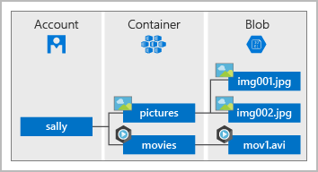

Azure Storage offers different access tiers for your blob storage, helping you store object data in the most cost-effective manner. The available access tiers include:

* **Hot access tier**: Optimized for storing data that is accessed frequently (for example, images for your website).
* **Cool access tier**: Optimized for data that is infrequently accessed and stored for at least 30 days (for example, invoices for your customers).
* **Archive access tier**: Appropriate for data that is rarely accessed and stored for at least 180 days, with flexible latency requirements (for example, long-term backups).

The following considerations apply to the different access tiers:

* Only the hot and cool access tiers can be set at the account level. The archive access tier isn't available at the account level.
* Hot, cool, and archive tiers can be set at the blob level, during upload or after upload.
* Data in the cool access tier can tolerate slightly lower availability, but still requires high durability, retrieval latency, and throughput characteristics similar to hot data. For cool data, a slightly lower availability service-level agreement (SLA) and higher access costs compared to hot data are acceptable trade-offs for lower storage costs.
* Archive storage stores data offline and offers the lowest storage costs, but also the highest costs to rehydrate and access data.